# Online Appendix 3.A: R code demonstration of sensitivity/specificity concepts

This relates to Section 3.7 in the book. In the folder corresponding to this chapter, open the software folder, click on the file software.Rproj, which launches RStudio in the correct folder. [You do not have to worry about setting the default directory, etc. The project file takes care of these details.] Under the Files menu find the file mainBinaryRatings.R and open it (i.e., click on it). A listing of the file follows:

### Online Appendix 3.A.1: Code Listing

# MainBinaryRatings.R

rm( list = ls() ) # clear all variables

mu <- 1.5

zeta <- mu/2

seed <- 100

K1 <- 9

K2 <- 11

set.seed(seed)

z1 <- rnorm(K1)

z2 <- rnorm(K2) + mu

nTN <- length(z1[z1 < zeta])

nTP <- length(z2[z2 >= zeta])

Sp <- nTN/K1

Se <- nTP/K2

mu <- qnorm(Sp)+qnorm(Se)

cat("seed = ", seed,

"\nK1 = ", K1,

"\nK2 = ", K2,

"\nSpecificity = ", Sp,

"\nSensitivity = ", Se,

"\nEstimated mu = ", mu, "\n")

Line 3 sets mu <- 1.5 and line 4 sets zeta to mu/2 (mu corresponds to the  parameter of the equal variance binormal model and zeta corresponds to , the threshold parameter, both of which are described in the book Section 3.5). Lines 5 and 6 sets the seed of the random number generator to 100: this causes the random number generator to yield the same sequence of "random" numbers every time it is run. This is useful during initial code development and for demonstrating the various steps of the example (if seed <- NULL the random numbers would be different every time, making it harder for me, from a pedagogical point of view, to illustrate the steps). Lines 7 and 8 initialize variables K1 and K2, the number of non-diseased and diseased cases, respectively. In this example 9 non-diseased and 11 diseased cases are simulated. Later we will experiment with other values. Click on the grey area of the source code window to the left of the line label 9. This inserts a break point at line 9 and it show up visually as a red dot to the left of line number 8, Figure 1 (A). A break point is a debugging aid that causes program execution to stop at the first encountered break point. Source the file, Figure 1 (B).

Lines 9 and 10 call the built-in function rnorm() – for random sample(s) from a normal distribution - with argument K1, which yields K1 (9 in line 9) samples from a unit normal distribution . *Arguments to a function are always comma separated and contained within enclosing parentheses*. The sampled values are assigned to the variable z1 (for z-samples for non-diseased cases with *t* = 1; *t* is the truth subscript). The corresponding samples for the diseased cases, line 10, denoted z2, are obtained using rnorm(K2) + mu. Alternatively one could have used rnorm(K2, mean = mu), which cause the value of mu to override the default value - zero - of the mean of the normal distribution in function rnorm. Since mu was initialized to 1.5, this line yields 11 samples from a normal distribution with mean zero and unit variance and adds 1.5 to all samples (if one wishes to sample from a distribution with a different variance, for example "3", one needs to also insert the standard deviation argument, e.g., sd = sqrt(3), in the call to rnorm()). The modifications to the default values can be inserted, separated by commas, *in any order*, but the names mean and sd must match; try typing rnorm(K1, mean1 = 0) or rnorm(K1, Mean = 0) in the console window, one should see the following error messages:

### Online Appendix 3.A.2: Code Snippet

> rnorm(K1, mean1 = 0)

Error in rnorm(K1, mean1 = 0) : unused argument (mean1 = 0)

> rnorm(K1, Mean = 0)

Error in rnorm(K1, Mean = 0) : unused argument (Mean = 0)

This is R’s way of saying that one has supplied an argument it does not understand. One also sees that R is case sensitive.

|  |  |
| --- | --- |
| (A) | (B) |

Figure : Plot A: Screen shot of RStudio window after inserting break point at line 9; note the red dot indicating the position of the break point. Plot B: Screen shot after clicking on Source; program has halted at line 9 and current values of variables are displayed in the Environment panel.

Notice the appearance of appropriate values in the Environment window. *Line 11 looks complicated but it is important to understand it.* For convenience it is reproduced below:

nTN <- length(z1[z1 < zeta])

*One always starts by trying to understand the right hand side of the assignment operator* <- *and one always work from inside out.* Click Next two times to advance the code pointer to line 11.The innermost statement in the "mess" on the right hand side is z1 < zeta: using the cursor, select it (and nothing else!) and click on the Run button, or type z1 < zeta in the Console window. In either case one should see the following (if not, check the seed values, numbers of cases etc., to exactly match the above code listing):

[1] TRUE TRUE TRUE FALSE TRUE TRUE TRUE TRUE TRUE

There are 9 elements in this output corresponding to the 9 non-diseased cases. Now select z1 (and nothing else!) and click on the Run button. You should see the following:

[1] -0.5022 0.1315 -0.0789 0.8868 0.1170 0.3186 -0.5818 0.7145 -0.8253

Again, there are 9 elements in the output. The starting [1] is R’s way of saying that the 1st element of the 9-dimensional array is -0.5022, the 2nd element is 0.1315, etc. Since the value of the first element of the array (i.e., -0.5022) is less than zeta (zeta = mu/2 = 0.75), the 1st element of the 9-dimensional *logical* array z1 < zeta is TRUE. The same is the case for all other elements of the array with one exception: the 4th element of the z1 array is 0.8868, and since this is greater than zeta, the corresponding element of z1 < zeta is FALSE. [One can now appreciate why the author took the precaution of “freezing” the seed variable at 100 at line 4. Otherwise randomness would make it impossible to explain the code at this level.]

Working outwards, one sees that z1 < zeta is surrounded by square brackets. *Square brackets [] are used to index (or subscript) the variable to the left of the opening square bracket*, which happens to be z1. So z1[1] would be -0.5022, the 2nd element z1[2] would be 0.1315 and so on (unlike C++, IDL and some other languages, arrays in R are indexed starting with unity, not zero). Interestingly, R allows the indexing variable to be a logical (i.e., TRUE/FALSE) array. R keeps those elements whose index is TRUE and discards those elements whose index is FALSE. With this knowledge under one's belt, select the variable z1[z1 < zeta] and click on the Run button; one should see the following:

> z1[z1 < zeta]

[1] -0.5022 0.1315 -0.0789 0.1170 0.3186 -0.5818 0.7145 -0.8253

This time there are only 8 elements in this output corresponding to the 8 non-diseased cases which yielded TRUE in the logical comparison. Notice that the value 0.8868, which did not satisfy the inequality z1 < zeta, has been discarded. The resulting array z1[z1 < zeta] is 8-dimensional. In summary, *the construct z1[z1 < zeta] selects all elements of the z1 array that satisfy the inequality z1 < zeta*.

Working outwards, one sees that z1[z1 < zeta] is *itself* enclosed in parentheses: (). In R parentheses are used to pass the pass an argument (or multiple arguments, separated by commas) to the function whose name occurs to the left of the opening parenthesis. This happens to be the R function length(), which as expected yields the length of the enclose array, 8 in our case. Select length(z1[z1 < zeta]) and click on Run:

> length(z1[z1 < zeta])

[1] 8

As always, the final result on the right hand side is assigned to the left hand side using the assignment operator <-. The left hand side of line 11 is the variable nTN, the number of true negative decisions (one cannot use the hash tag symbol as in the book, as this is reserved for comments; there are limitations to any programming language). Thus line 11 results in nTN being assigned the value 8. Click on Next in the Console window to execute line 11 and print out nTN (select it and click Run) Using similar logic, line 12 results in nTP, the number of true positives decisions, being assigned the value 10. Click Next in the Console window. Line 13 calculates *specificity* by dividing the number of TN decisions by the number of non-diseased cases. Line 14 calculates *sensitivity* by dividing the number of TP decisions by the number of diseased cases. Line 15 implements book Eqn. 3.21. Line 16 - 21 prints out these values with descriptive messages. Click Continue in the Console window to execute the rest of the code.

### Online Appendix 3.A.3: Executing the entire source code file

The purpose of the preceding section was to explain the working of the program. *One can always examine how the program works by inserting breakpoints and sourcing the code, or one can run each line in turn by clicking on the* Run *button; the cursor will automatically advance to the next line to be executed.* *The* Run *button always executes the selected section of code or the line at the position of the cursor. Selecting multiple contiguous lines and clicking* Run *also works.*

Once satisfied that the program is working as expected, and one wishes to Run all the lines, exit debug mode, if necessary, by clicking on Stop in the Console window, remove the breakpoint by clicking on it, then click on Source, which executes all lines in the file. [One can tell if one is in debug mode if the prompt has the word Browse in it.]

> source(...)

seed = 100

K1 = 9

K2 = 11

Specificity = 0.8888889

Sensitivity = 0.9090909

Estimated mu = 2.555818

# Online Appendix 3.B: Calculating confidence intervals for sensitivity and specificity, or equivalently, for FPF and TPF

This relates to Section 3.10 in the book. Open file mainConfidenceIntervals.R.

### Online Appendix 3.B.1: Code Listing

# mainConfidenceIntervals.R

rm( list = ls() )

options(digits=6)

seed <- 100

set.seed(seed)

alpha <- 0.05

K1 <- 99

K2 <- 111

mu <- 5

zeta <- mu/2

cat("alpha = ", alpha,

"\nK1 = ", K1,

"\nK2 = ", K2,

"\nmu = ", mu,

"\nzeta = ", zeta, "\n")

z1 <- rnorm(K1)

z2 <- rnorm(K2) + mu

nTN <- length(z1[z1 < zeta])

nTP <- length(z2[z2 >= zeta])

Sp <- nTN/K1

Se <- nTP/K2

cat("Specificity = ", Sp,

"\nSensitivity = ", Se, "\n")

# Approx binomial tests

cat("approx 95% CI on Sp = ",

-abs(qnorm(alpha/2))*sqrt(Sp*(1-Sp)/K1)+Sp,

+abs(qnorm(alpha/2))*sqrt(Sp*(1-Sp)/K1)+Sp,"\n")

# Exact binomial test

ret <- binom.test(nTN, K1, p = nTN/K1)

cat("Exact 95% CI on Sp = ",

as.numeric(ret$conf.int),"\n")

# Approx binomial tests

cat("approx 95% CI on Se = ",

-abs(qnorm(alpha/2))*sqrt(Se*(1-Se)/K2)+Se,

+abs(qnorm(alpha/2))*sqrt(Se*(1-Se)/K2)+Se,"\n")

# Exact binomial test

ret <- binom.test(nTP, K2, p = nTP/K2)

cat("Exact 95% CI on Sp = ",

as.numeric(ret$conf.int),"\n")

The 1st 23 lines are similar to those in mainBinaryRatings.R in listing 3.A.1. The options statement at line 3 limits the number of displayed digits to 6. Lines 26 - 28 calculates the *approximate* 95% CI for specificity (1-FPF) using Eqn. 3.43. Note the usage of the absolute value of the qnorm() function; qnorm is the *lower* quantile function for the unit normal distribution, identical to  and  is the *upper* quantile function for the unit normal distribution. Lines 31 – 33 calculate and print the corresponding *exact* confidence interval, using the function binom.test(); one should look up the documentation on this function for further details (in the Help panel – lower right window - start typing in the function name and RStudio should complete it) and examine the structure of the returned variable. The 4th element of the list is the desired confidence interval. The function as.numeric() is needed to extract the value.

> str(ret)

List of 9

$ statistic : Named num 110

..- attr(*, "names")= chr "number of successes"

$ parameter : Named num 111

..- attr(*, "names")= chr "number of trials"

$ p.value : num 1

$ conf.int : atomic [1:2] 0.951 1

..- attr(*, "conf.level")= num 0.95

$ estimate : Named num 0.991

..- attr(*, "names")= chr "probability of success"

$ null.value : Named num 0.991

..- attr(*, "names")= chr "probability of success"

$ alternative: chr "two.sided"

$ method : chr "Exact binomial test"

$ data.name : chr "nTP and K2"

- attr(*, "class")= chr "htest"

The remaining code repeats these calculations for sensitivity (TPF).

# Online Appendix 3.C: Introduction to R/RStudio, part II

Part I of the introduction is in the Online Appendix to Chapter 1.

### Online Appendix 3.C.1: The normal distribution in R

This demo relates to book Section 3.6.

A quick way to learn about available statistical distributions in R is to click on the Help tab in the bottom-right RStudio window and start typing "distributions" in the search box (indicated by the magnifying glass in the Mac operating system). By the time the author typed "dis", RStudio popped-up up some matches, ranging from "discoveries" to "distributions". When the author selected "distributions" it shows a page of available statistical distributions ranging from the *beta* to the *Weibull* distribution. The one the author is interested in is the *normal* distribution, and the entry dnorm is color coded as a link to a webpage (RStudio is actually displaying pages from the official R help site: <http://www.r-project.org/> ). Clicking on dnorm gives Figure 2 (the author is only showing the first few lines; the user can look at the whole page on one's computer):

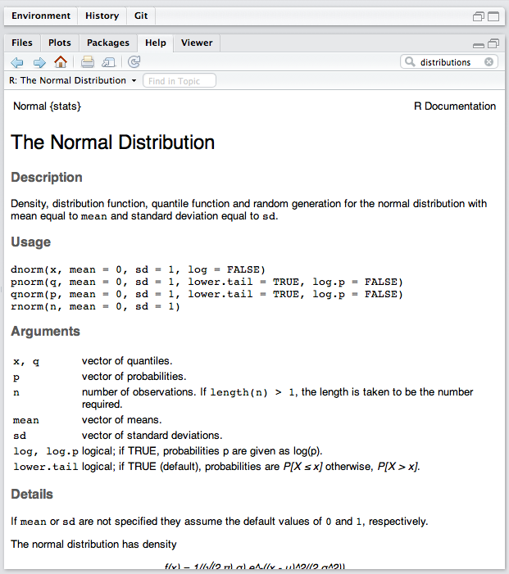

Figure : Help page for functions pertaining to the normal distribution.

There are four functions related to the normal distribution, all of which end with norm (for normal distribution). The prefixes are d, for density, p, for probability, q for quantile and r for random (sample is implied). The same convention is followed for the other distributions. You already have some familiarity with rnorm(), so let us start with it. The complete function call is:

rnorm(n, mean = 0, sd = 1)

Here rnorm() is a function (the opening parenthesis signals that the variable preceding it is the name of a function). Think of a function as a black box that takes some input variables, contained within the parentheses, termed *arguments*, and returning, something useful. With rnorm the minimum input is the desired number of samples, which is what the argument n stands for. You could enter rnorm(n = 10) to get 10 samples from  or one could omit the n = and simply enter rnorm(10) which would work just as well, but rnorm(x = 10) would generate an error:

Error in rnorm(x = 10) : unused argument (x = 10)

This is because the function is not expecting an argument named x. If one does not supply the remaining quantities, the default values denoted by the = signs in Figure 2 are used. Therefore, rnorm(10) is equivalent to rnorm(n = 10, mean = 0, sd = 1). Now if one types (or copies and pastes) these commands conscientiously into the Console window, one sees different numbers, because the random number generator produces different sequences of numbers every time it is called. To prevent this from happening, try running the following commands:

seed <- 1;set.seed(seed); rnorm(10)

set.seed(seed); rnorm(n = 10, mean = 0, sd = 1)

Try it! Copy and paste the above two lines, one line at a time, into the Console window, and press the enter/return key. This time one sees the same sequence of 10 random numbers. The author stresses that this pedagogical device is used only to explain how things work; *one should never reset the seed more than once when conducting actual simulations.* To start with a completely random seed (determined from the system time) use

seed <- NULL;set.seed(seed);

The author trusts by now one is seeing at least one distinction between the assignment operator <- and the = operator. The = operator is used to override default values of function arguments. To sample from a normal distribution with mean 1.5 and variance 2, denoted  use the following equivalent forms:

seed <- 1;set.seed(seed); rnorm(10, 1.5, sqrt(2))

seed <- 1;set.seed(seed); rnorm(10, mean = 1.5, sd = sqrt(2))

The first form involves less typing, but one has to be sure that the arguments are in the correct order, i.e., the first one must correspond to n, the second to mean, etc. If one has not guessed it, sqrt() stands for the square root function [rnorm needs the standard deviation, not the variance; the standard deviation is the square root of the variance; try typing sqrt(49) in the Console window; one should get 7]. The reader should study the examples below:

> set.seed(seed = 1);rnorm(n = 10, mean = 1.5, sd = sqrt(2)) # example 1

[1] 0.614 1.760 0.318 3.756 1.966 0.340 2.189 2.544 2.314 1.068

> set.seed(seed = 1);rnorm(10, 1.5, sqrt(2)) # example 2

[1] 0.614 1.760 0.318 3.756 1.966 0.340 2.189 2.544 2.314 1.068

> set.seed(seed = 1);rnorm(1.5, 10, sqrt(2)) # example 3

[1] 9.11

> set.seed(seed = 1);rnorm(mean = 1.5, n = 10, sd = sqrt(2)) # example 4

[1] 0.614 1.760 0.318 3.756 1.966 0.340 2.189 2.544 2.314 1.068

The third example, where the order is not what one intended, rnorm(1.5, 10, sqrt(2)), yielded one sample from the normal distribution with mean 10 and variance 2. You got one sample, as it is difficult for R to satisfy your request to provide 1.5 samples. The fourth example shows that as long as one also specifies the parameter names, shuffling the order of the arguments has no effect. The style of programming is entirely up to the reader. As the saying goes, “there are more than one ways of skinning a cat”.

### Online Appendix 3.C.2: The mean, variance, and standard deviation functions

Click on the file menu in the lower-right RStudio window and select the file mainSamplingNormalDistributions.R, which is reproduced below.

### Online Appendix 3.C.3: Code Listing

#mainSamplingNormalDist.R

rm(list = ls()); set.seed(1); options(digits=3)

# get 2 sets of 10 random samples from the unit normal distribution

x <- rnorm(10);cat("1st set of 10 random samples are \n",x,"\n\n")

x <- rnorm(10);cat("2nd set of 10 random samples are \n",x,"\n\n")

# mean and standard deviation of 10,000 new samples from the unit normal distribution

cat("mean of 10,000 new samples =", mean(x1 <- rnorm(10000)),"\n")

cat("std. of above 10,000 samples =", sqrt(var(x1)),"\n")

Line 2 does three things (always in left-to-right order): it clears all variables; it sets the seed to unity, and it limits displayed numbers to 3 decimal places. Line 3 is a comment explaining what lines 4 and 5 do. Line 4 has two statements separated by a semi-colon. The first statement generates 10 random samples from a unit normal distribution and assigns the values to the variable x. The second statement prints the helpful remark "1st set of 10 random samples are \n" where the newline character assures that the numbers themselves will appear on a separate line. The values are printed because of the presence of the variable x in the cat argument list. Specifically, the call to cat was:

cat("1st set of 10 random samples are \n",x,"\n\n")

As noted earlier, cat stands for concatenate and print. So what is there to concatenate and print? One starts with the string ("1st set of 10 random samples are \n" which is the helpful message followed by the newline character; the next argument is x (notice that arguments are *always* comma separated), which in our case is an array with 10 elements; the final argument is two consecutive newline characters, which is a convenient way to achieve clear separation between the outputs of line 4 and 5. [A subtle point at this stage: the assignment in Line 5 overwrites the previously assigned values to the variable x in line 4.]

Line 7 is:

cat("mean of 10,000 new samples) =", mean(x1 <- rnorm(10000)),"\n")

It prints out a helpful message followed by a number. The number is the value shown below:

mean(x1 <- rnorm(10000))

Again, starting from inside out, rnorm(10000) yields ten-thousand samples from the unit normal distribution. This huge array is assigned to the variable x1. The only reason for doing so is one needs the huge array x1 at line 8 where one calculates its standard deviation - so one needs to save it. Finally this array is passed to the mean() function, which as one may have guessed, calculates the mean (average) of the array. Since this is the mean of a large number of samples from a unit normal distribution, one expects a value close to zero. Line 8 prints a helpful message followed by the square root sqrt() of the variance var() of the huge array x1. So one sees that it is possible to calculate the variance and pass the result directly to the square root function. Since this is the standard deviation of a large number of samples from a unit normal distribution, one expects a value close to unity. [In case one is wondering, R does have a standard deviation function, sd(), but the author chose not to use it.] Sourcing this file (“sourcing” is RStudio-speak for clicking on the Source button with the file in question in the foreground) yields the following output.

### Online Appendix 3.C.4: Code Output

> source('~/book/3 R_RStudio/Software/mainSamplingNormalDistribution1.R')

1st set of 10 random samples are

-0.626 0.184 -0.836 1.6 0.33 -0.82 0.487 0.738 0.576 -0.305

2nd set of 10 random samples are

1.51 0.39 -0.621 -2.21 1.12 -0.0449 -0.0162 0.944 0.821 0.594

mean of 10,000 new samples = -0.00731

std. of above 10,000 samples = 1.01

As expected, the mean is close to zero and the standard deviation is close to unity.

### Online Appendix 3.C.5: Quantiles and CDF of the normal distribution

Open the file mainPropertiesUnitNormal.R whose listing follows:

### Online Appendix 3.C.6: Code Listing

#MainPropertiesUnitNormal.R

rm(list = ls());library(ggplot2)

cat("2.5 percentile of distribution =", qnorm(0.025), "\n")

cat("97.5 percentile of distribution =", qnorm(1-0.025), "\n")

cat("P(X<0) =", pnorm(0),"\n")

cat("P(X<-1.96) =", pnorm(-1.96),"\n")

cat("P(X<-Infinity) =", pnorm(-Inf),"\n")

cat("P(X<Infinity) =", pnorm(Inf),"\n")

# plot the CDF

x <- seq(-3, 3, by = 0.01)

curveData <- data.frame(x = x, CDF = pnorm(x))

cdfPlot <- ggplot(data = curveData, mapping = aes(x = x, y = CDF)) + geom_line()

print(cdfPlot)

Line 3 illustrates the usage of the quantile function of the normal distribution, called qnorm(). This is the  function defined in book Equation 3.9. Again, cat() is used to print a helpful message regarding the variable being printed. Line 3 gives the 2.5th percentile of the unit normal distribution, which is approximately -1.96, i.e., 2.5 percent of the distribution is below -1.96. If one selected (or simply put the cursor on the line) and clicked Run, one sees:

> cat("2.5 percentile of distribution =", qnorm(0.025), "\n")

2.5 percentile of distribution = -1.96

Likewise, Line 4 yields the 97.5 percentile of the unit normal distribution, roughly +1.96. Line 6 illustrates the usage of the cumulative distribution function (CDF), the function of the unit normal distribution, book Equation 3.7, implemented in pnorm(). To demonstrate that pnorm() and qnorm() are indeed inverse functions, try

> p <- 0.2; pnorm(qnorm(p))

[1] 0.2

> x <- 2.5111; qnorm(pnorm(x))

[1] 2.5111

The second form may not always work: if the magnitude of x is large, then pnorm can be so close to unity (or zero) that due to finite precision it is exactly unity (or zero), and the qnorm() function will give plus or minus infinity, respectively:

> x <- 25111; qnorm(pnorm(x))

[1] Inf

> x <- -25111; qnorm(pnorm(x))

[1] -Inf

If one sources the file mainPropertiesUnitNormal.R one gets the following output (and a plot of CDF in the Plots window, corresponding to one of the plots in book Figure 3.1):

### Online Appendix 3.C.7: Code Output

> source(…)

2.5 percentile of distribution = -1.96

97.5 percentile of distribution = 1.96

P(X<0) = 0.5

P(X<-1.96) = 0.025

P(X<-Infinity) = 0

P(X<Infinity) = 1

# Online Appendix 3.D: Plotting in R

Open the file mainUnitNormalPdfCdf.R in the source-code window. The listing follows:

### Online Appendix 3.D.1: Code Listing

# mainUnitNormalPdfCdf.R

rm(list = ls())

library(ggplot2)

x <- seq(-3,3,0.01)

pdf <- dnorm(x)

cdf <- pnorm(x)

df <- data.frame(

z = c(x, x), all = c(pdf, cdf),

group = c(rep("pdf", length(pdf)),

rep("CDF", length(cdf)))

)

p <- ggplot(df, aes(x = z, y = all, color = group)) +

geom_line(data = df, size = 2) + xlab("z") + ylab("pdf/CDF") +

geom_vline(xintercept = 1, linetype = 2, size = 2) +

scale_colour_manual(values=c("black","darkgrey")) +

theme(legend.title = element_blank(), legend.position = c(0.2, 0.95),

legend.key.size = unit(1.5, "lines"), legend.text=element_text(size=20, face = "bold"),

legend.direction = "horizontal") +

theme(axis.title.y = element_text(size = 25,face="bold"),

axis.title.x = element_text(size = 30,face="bold")) +

scale_x_continuous(expand = c(0, 0)) +

scale_y_continuous(expand = c(0, 0))

print(p)

Line 5 uses dnorm(), which is the density or *pdf* function, book Equation 3.6. So the function to be plotted by the curve() function is the unit normal density function . The second argument is xlim=c(-2,4) which sets the internal parameter xlim of the curve() function to a vector with elements -2 and 4. This is the first time one is seeing it, but the purpose of the R function c() is to *collect* the values inside the parenthesis (recall, a function always requires a parenthesis to enclose any arguments) into an array (the author has confused cat() with c(), with obvious negative consequences). For example, c(1,2,4) yields a one-dimensional array with elements 1, 2 and 4, respectively. If one assigns them to a variable t, then t[1] has the value 1, t[2] has the value 2 and t[3] has value 4. Here is the example in ready to copy and paste form for direct use in one's Console window:

### Online Appendix 3.D.2: Code snippet

> t <- c(1,2,4)

> t[1];t[2];t[3];t[4]

[1] 1

[1] 2

[1] 4

[1] NA

[Notice that the attempt to get an element that was not defined yielded a NA, for not available. This is a useful feature of R that some other languages (ex. IDL, C++) lack.] Returning to the curve() function, the parameter xlim stands for "limits for x-axis". So one is asking the curve() function to plot values in the x-axis range  . The next argument is col = ‘blue’, which sets the color of the plot. The next argument is ylab = “pdfs”, the label for the y-axis, and the final argument is xlab = "z-sample", the label for the x-axis.

Line 5 is a similar call to curve(), but this time the function being plotted is dnorm(x, mean = 1.5), the *pdf* for the diseased cases. An additional argument to curve, namely add = TRUE, ensures that this plot appears superposed on the one just created by line 4. When add = TRUE the existing plotting parameters (specified in line 4) are reused. That is why one does not need to re-specify xlim=c(-2,4). Without it the second plot appears in a different window and R would use the default values for the xlim parameter, yielding a strange looking *pdf* curve (try removing the add = TRUE part; the reader should be convinced that the plot is correct, it simply looks strange because the relevant range of the x-axis is not being shown). Also notice that multiple plots are conveniently organized under the Plots tab, and one can use the arrows under the Plots tab to navigate through them. When the plots keep piling up one may wish to discard them all by clicking on the Clear All button (the broom symbol); or one can delete individual plots using the red-cross button next to the Export tab.

Enough said. Time to Source the code. The result is book Figure 3.1, which appears under the Plots tab. Using the Export tab under the Plots menu, the author copied the plot to the clipboard and pasted it into his manuscript.

# Online Appendix 3.E: Getting help in R – Part I

How did I know what argument names to use (e.g., xlim)? I did not. The author entered curve in the search bar of the Help panel to find the help file for this function. Try it, Figure 3.

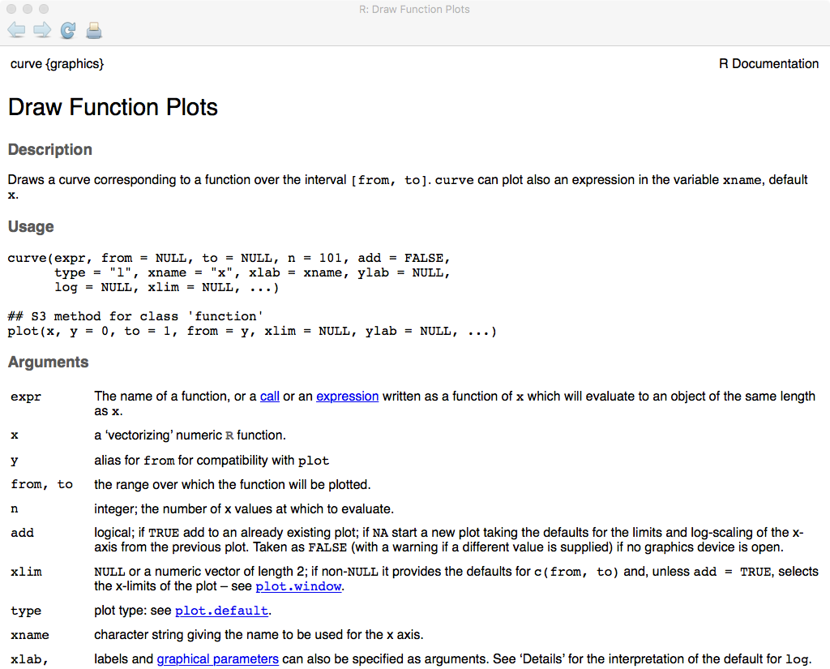

Figure : The help page for the curve function.

How did the author know to use curve in the first place? He did not. This is where a terse well-phrased Google search helps. Preceding the search with [R] can help narrow the search, and then enter one's phrase. For example, entering [R] plotting a function in the search bar of Google yielded as the top "hit" the help file for the curve() function:

http://stat.ethz.ch/R-manual/R-devel/library/graphics/html/curve.html

The ability to get help quickly is very important in the learning curve. The R documentation is terse, and many times the author has benefited from a quick search on the Internet. There are literally thousands of people using R, and chances are one's question has already been answered.

# Online Appendix 3.F: Getting help in R – Part II

The previous method works only if the function one is seeking help on is already available on disk and compiled by R. As part of its standard distribution R includes a lot of functions, but sometimes one needs to load a R-package, which is a collection of functions, not available in the basic distribution. Packages are extension to R developed by other researchers and made available on the CRAN website, in open-source fashion, to all users. One example the reader will see often in this book is the RJafroc package. This package, available on the CRAN website, https://cran.r-project.org/web/packages/RJafroc/index.html, encapsulates most of the analyses techniques described in this book, hiding unnecessary details from the user. This section gives an example of how to get help regarding this package, and by extension, enabling the reader to get help about any package.

### Online Appendix 3.F.1: Installing a package

Click packages in the lower right RStudio window; click Install and start typing "RJa..", before one gets far, one should see RJafroc in the pop-up menu. Select it: one should see some activity like:

### Online Appendix 3.F.2: Code Output

> install.packages("RJafroc")

trying URL 'https://cran.rstudio.com/bin/macosx/mavericks/contrib/3.3/RJafroc_0.1.1.tgz'

Content type 'application/x-gzip' length 1072212 bytes (1.0 MB)

==================================================

downloaded 1.0 MB

The downloaded binary packages are in

/var/folders/d1/mx6dcbzx3v39r260458z2b200000gn/T//Rtmp4XwA1R/downloaded_packages

This shows that the required package files have been *downloaded* to one's disk. One also needs to insert a library command, as in the code below, which causes the package to be read from disk and *compiled* to binary instructions; also, required help files are loaded. The following file mainPackage.R is an example:

### Online Appendix 3.F.3: Code Listing

rm(list = ls()) #mainPackage.R

library(RJafroc)

fileName <- "VanDyke.lrc"

rocData <- ReadDataFile(fileName, format = "MRMC")

Line 2 compiles the package so that all of its functions are available from within R. Source the code.

### Online Appendix 3.F.4: Code output

> source(…)

Loading required package: tools

Loading required package: xlsx

Loading required package: rJava

Loading required package: xlsxjars

Loading required package: ggplot2

Loading required package: stringr

Loading required package: shiny

The multiple "Loading required package:" come from packages that RJafroc needs; for example ggplot2 allows one to generate exquisite plots; ggplot2 is a sophisticated R plotting package; gg stands for Grammar of Graphics1, which is a whole book in itself that one does not need to understand in depth; one just needs to know enough to use it. The package xlsx allows reading and writing to Excel files. You may not see the above detailed listing on subsequent source commands. If a package is already loaded, i.e., in compiled form in working memory, then it is not loaded again, so the library command can be kept permanently, just in case it is needed.

# Online Appendix 3.G: What to do if a package is missing

Sometimes when one sources a file one might get a listing like this:

### Online Appendix 3.G.1: Code Output

> source(…)

Find out what's changed in ggplot2 at

http://github.com/hadley/ggplot2/releases.

Loading required package: shiny

Loading required package: xlsx

Loading required package: rJava

Loading required package: xlsxjars

Loading required package: stats4

Error in library(binom) : there is no package called ‘binom’

The last line is an error message saying, effectively, "can't find a package called binom". The solution is to install the package; one can do it in one line, just type in install.packages("binom") into the Console window and hit return, or go through the RStudio interface, as described in Online Appendix 3.F.1.

### Online Appendix 3.G.2: Getting help on a function

Line 4 of file mainPackage.R uses the ReadDataFile() function. To get help on this function proceed as follows. Click on the Help tab in the lower right RStudio window. Start typing in "ReadDa…" and before one gets far RStudio will show the full function name, possibly with other near matches, in a pop-up window; select it to obtain Figure 4.

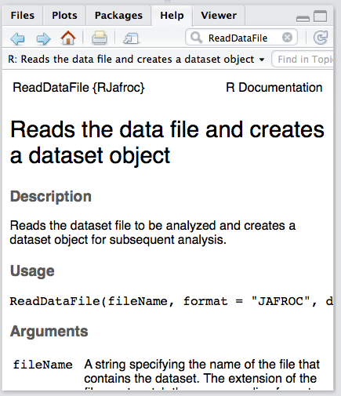

Figure : Viewing the help file for the ReadDataFile() function.

Since this display is confined to a small window, there is only so much one can show. Look carefully at the above figure, and just below Packages, next the printer icon one sees an icon perhaps best described as "an outward pointing arrow on a document". Hovering the mouse pointer over this icon pops-up the message "Show in new window". Click in this icon to get Figure 5, the listing of the help file in an independent window, that can be re-sized for ease of reading.

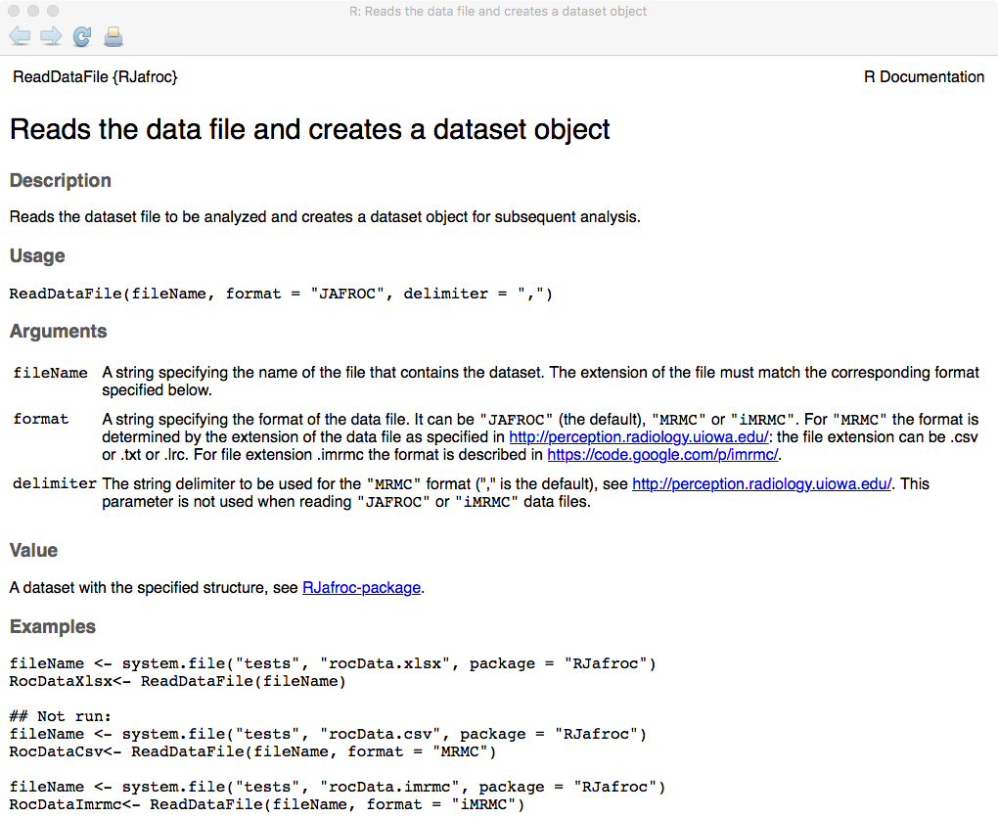

Figure : Viewing the help file in a new window (partial, the bottom of the window can be seen by scrolling).

### Online Appendix 3.G.3: Interpreting the help file

The window has a number of hyperlinks, clicking on which takes one to other documentation files. After a brief description of what the function does, under Usage one sees:

ReadDataFile(fileName, format = "JAFROC", delimiter = ",")

The function takes a filename, basically the name of an existing disk file containing the data, the default format is "JAFROC" and the default delimiter is ",". At line 4 in mainPackage.R, format is overridden by format = "MRMC". Under Arguments in Figure 5 one sees:

For "MRMC" the format is determined by the extension of the data file as specified in <http://perception.radiology.uiowa.edu/>: the file extension can be .csv or .txt or .lrc. For file extension .imrmc the format is described in <https://code.google.com/p/imrmc/>.

With appropriate specification of the format argument, the function can read data in any of the existing formats.

Under Values Figure 6 lists the quantity returned by the function, in this example an RJafroc dataset object. There is a hyperlink to RJafroc-package that defines this object. Basically it is a general data format that can accommodate any of the existing data collection paradigms, specifically: ROC, FROC, LROC and ROI.

Under examples are listed some usages of the function. *These can literally be copied and pasted into the Console window to see the function at work*. As an example:

fileName <- system.file("tests", "rocData.xlsx", package = "RJafroc")

RocDataXlsx<- ReadDataFile(fileName)

On pressing the ⏎ key there is no obvious activity, but if one looks in the Environment window, one sees Figure 6:

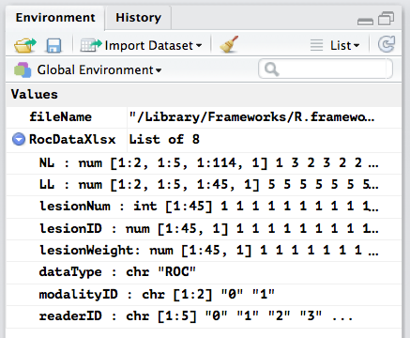

Figure : Result of running the example code in the help file.

To summarize, the function reads a data file and returns a dataset object. The dataset consists of two modalities, five readers, 45 diseased and 114-45 = 69 diseased cases. This is the Van Dyke dataset2, made famous in the ROC methodology field due to the work of Dorfman, Hillis, Berbaum and colleagues.

# Online Appendix 3.H: Shaded distributions in R

Open the file mainShadedPlots.R and Source it. You should see book Figure 3.3. The code is complex and uses the R package called ggplot2. A version that is long-winded but simpler to follow is in mainShadedPlotsSimple.R. *The basic idea is to define the vertices of a polygon that encloses the region to be shaded and use the* polygon() *function to fill it in with a specified color.* Each polygon vertex requires an *x* and a *y* coordinate stored in two arrays called cord.x and cord.y, respectively. [As a past C programmer, the author cringes at the practice in R of using the decimal point as part of a variable name, but it is what it is; one can use the underscore character, or even better, good use of upper-case and lower case, termed "CamelCase" to ensure that one's variable names are more readable, e.g. variableName.]

If the last vertex is identical to the first vertex the polygon is closed; if not, R will join the last point to the first point with a straight line. Since the code is a little long, the author shows it in parts. The first 7 lines are:

### Online Appendix 3.H.1: Code Listing

# mainShadedPlotsSimple.R

rm(list = ls())

mu <- 3;sigma <- 1;zeta <- 1

step <- 0.1

lowerLimit<- -1 # lower limit

upperLimit <- mu + 3*sigma # upper limit

Lines 1-3 perform standard initializations: ,  and . Line 4 initializes the step variable to 0.1; it determines the spacing of the x-coordinates defining the vertices of the polygon. Lines 6-7 define the variables lowerLimit (for lower limit) and upperLimit (for upper limit); these are set to values covering the useful range of z-samples to be plotted (-1 and 6, respectively, see x-axis of book Figure 3.3). Shown next are lines 9-18:

### Online Appendix 3.H.2: Code Listing

seqNor <- seq(zeta,upperLimit,step)

cord.x <- c(zeta, seqNor,upperLimit)

# need two y-coords at each end point of range;

# one at zero and one at value of function

cord.y <- c(0,dnorm(seqNor),0)

curve(dnorm(x,0,1),xlim=c(lowerLimit,upperLimit),col='blue',

ylab = "pdfs", xlab ="z-sample")

polygon(cord.x,cord.y,col='blue')

curve(dnorm(x,mu,sigma),xlim=c(lowerLimit,upperLimit), add = TRUE, col = 'red')

Line 9 uses the seq() function (for sequence) to generate a sequence of values starting with zeta, ending with upperLimit and with spacing step. In the current example, because zeta is 1, the sequence is 1, 1.1, 1.2, ….., 4.9, 5. This array is assigned to the variable seqNor (for sequence for non-diseased cases). Line 10 pads, using the c() function, seqNor with an extra zeta (with value 1) at the beginning of the array and an extra upperLimit (with value 5) at the end of the array and assigns the result to the variable cord.x. The padding is for the following reason: at x = 1 one needs two values of y: 0 and , respectively, which define the left edge of the region to be shaded blue in book Figure 3.3. Likewise there is a tiny downward jump at the right edge of the region to be shaded blue, with y coordinates equal to and 0, respectively (one uses the convention of always going counter-clockwise in enumerating the vertices of the polygon). The dnorm() function, which implements the  function, fills in the required values of *y*, corresponding to the upper curved portion of the blue-shaded region shown in book Figure 3.3. The result is assigned to the variable cord.y. The values of cord.y are (to see this select lines 1-13 and click on Run; then select cord.y and click on Run):

> cord.y

[1] 0.00e+00 2.42e-01 2.18e-01 1.94e-01 1.71e-01 1.50e-01 1.30e-01 1.11e-01 9.40e-02 7.90e-02 6.56e-02 5.40e-02 4.40e-02 3.55e-02

[15] 2.83e-02 2.24e-02 1.75e-02 1.36e-02 1.04e-02 7.92e-03 5.95e-03 4.43e-03 3.27e-03 2.38e-03 1.72e-03 1.23e-03 8.73e-04 6.12e-04

[29] 4.25e-04 2.92e-04 1.99e-04 1.34e-04 8.93e-05 5.89e-05 3.85e-05 2.49e-05 1.60e-05 1.01e-05 6.37e-06 3.96e-06 2.44e-06 1.49e-06

[43] 8.97e-07 5.36e-07 3.17e-07 1.86e-07 1.08e-07 6.18e-08 3.51e-08 1.98e-08 1.10e-08 6.08e-09 0.00e+00

This is a 53-dimensional array (glance at Environment panel) whose first and last elements are zeroes (these were deliberately set by us using the zero-padding at the two ends of the array shown on the right hand side of line 13) and the intervening elements were obtained by applying the  function, i.e., dnorm, to seqNor.

Lines 14-15: these plot the *pdf* function over the x-range lowerLimit to upperLimit, in color blue, and labels the axes appropriately. Now here is an example of how R does away with the continuation character for long lines of code, which is necessary in some other languages. Basically R interprets a complex statement extending over several lines one line at a time. If the first line makes sense, R evaluates it; otherwise it reads the second line, and if still no sense, the third line, etc. [R tries really hard to make it easy for the user but one has to be careful how one splits the long sentence; best to leave it ending with a comma, so R is forced to read the nect line.] In the current example, the first line does not make sense because the opening bracket of the curve() function is not closed at this point, so R reads the second line, and since that yields a complete statement (the bracket is closed) R evaluates it. Line 16 uses the polygon() function to superpose the defined polygon over an existing plot and fills it in with the color blue. Finally, line 18 draws the *pdf* of the diseased distribution in red and superposes it on the existing plot (add = TRUE argument is needed here).

To see what is happening, exit debug mode, clear any existing break points and insert a break point at line 18 (in case one has forgotten, click on the gray area to the left of the line number; a red dot should appear to the left of the line number) and click on Source. One should see Figure 7. R has completed the defined open polygon by automatically connecting the last point (6,0) to the first point (1,0) with a vertical line.

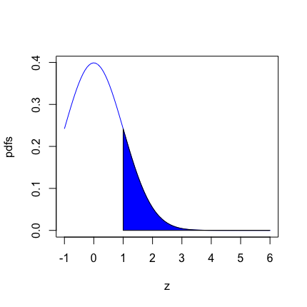

Figure : Result of running lines 1 – 17 of code in mainShadedPlotsSimple.R.

It has been demonstrated how to shade a portion of the non-diseased *pdf* from  to infinity. One's cursor should be at line 18. Click on Next in the debug window (under Console). You should see the red colored line for the *pdf* of the diseased distribution superposed on the preceding figure (not shown).

Your cursor should be at line 20. Shading in the diseased distribution (i.e., under the red curve) is a little more complicated as one needs to shade the enclosed portion above the non-diseased distribution (blue curve) differently from that below it. The first order of business is to find the point at which the two curves cross each other, roughly *z* = 1.5 according to book Figure 3.3. Lines 20-21, reproduced below, find the crossing point:

crossing <- uniroot(function(x) dnorm(x) - dnorm(x,mu,sigma),

lower = 0, upper = 3)$root

It uses the one-dimensional root finding function uniroot() (a root is a zero-crossing of a function). The first argument of uniroot() is the function whose root is desired. In our example, the function is function (x) dnorm(x) - dnorm(x,mu,sigma), which defines function(x). In other words, one wishes to find that value of *x* at which the densities of the non-diseased and diseased pdf’s are identical. The other arguments are intended to help the function in finding the root. For example, lower = 0, upper = 3 says to restrict the search for the root to the range 0 to 3. The result is assigned to the variable crossing. Your cursor should be at line 20. Click on Next twice. Select crossing and click on Run:

Browse[2]> crossing

[1] 1.5

Browse[2]>

This value should come as no surprise. Since the separation of the two distributions is 3, they must, by symmetry, cross at 1.5.

Next comes the shading part. It will convenient to define the polygon explicitly and not leave it to R to make any assumptions about how to close the polygon. Lines 23 – 28 follow:

crossing <- max(c(zeta, crossing))

seqAbn <- seq(crossing,upperLimit,step)

cord.x <- c(seqAbn, rev(seqAbn))

# reason for reverse

# we want to explicitly define the polygon

# we dont want R to close it

Click on Next twice bringing the cursor to line 30. Line 24 defines seqAbn: it is the sequence 1.5, 1.6, 1.7, ….., 45.9, 6. Line 25 concatenates this array to the *reversed* array using the reverse function rev(). The result is assigned to cord.x which looks like: 1.5, 1.6, 1.7, ….., 5.9, 6, 6, 5.9, ……, 1.7, 1.6, 1.5, i.e., it starts at 1.5, extends to 6 and then returns to 1.5, all in steps of 0.1. You can confirm this by selecting cord.x and clicking Run.

Browse[2]> cord.x

[1] 1.5 1.6 1.7 1.8 1.9 2.0 2.1 2.2 2.3 2.4 2.5 2.6 2.7 2.8 2.9 3.0 3.1 3.2 3.3 3.4 3.5 3.6 3.7 3.8 3.9 4.0 4.1 4.2 4.3 4.4 4.5 4.6 4.7

[34] 4.8 4.9 5.0 5.1 5.2 5.3 5.4 5.5 5.6 5.7 5.8 5.9 6.0 6.0 5.9 5.8 5.7 5.6 5.5 5.4 5.3 5.2 5.1 5.0 4.9 4.8 4.7 4.6 4.5 4.4 4.3 4.2 4.1

[67] 4.0 3.9 3.8 3.7 3.6 3.5 3.4 3.3 3.2 3.1 3.0 2.9 2.8 2.7 2.6 2.5 2.4 2.3 2.2 2.1 2.0 1.9 1.8 1.7 1.6 1.5

Clear any break points, exit debug mode (red square button), insert a break point at line 30 and click on Source. Lines 30 – 33 show how one fills in the portion of book Figure 3.3 that is unconditionally red.

cord.y <- c()

for (i in seq(1,length(cord.x)/2)) {

cord.y <- c(cord.y,dnorm(cord.x[i],mu, sigma))

}

In line 30 one starts by declaring a NULL array with nothing in it, c(). Line 31 begins a for loop: it says, effectively, for (i in seq(1,length(cord.x)/2)) do the statements enclosed in the curly brackets. Now seq(1,length(cord.x)/2) evaluates to 1, 2, 3, ….., 44, 45, 46. Try it! Select seq(1,length(cord.x)/2, on line 34, being sure to get the brackets matched up, and click on Run. You will see:

Browse[2]> seq(1,length(cord.x)/2)

[1] 1 2 3 4 5 6 7 8 9 10 11 12 13 14 15 16 17 18 19 20 21 22 23 24 25 26 27 28 29 30 31 32 33 34 35 36 37 38 39 40 41 42 43 44

[45] 45 46

Browse[2]>

These define the values of i. For these values the following statement is executed:

cord.y <- c(cord.y,dnorm(cord.x[i],mu, sigma))

Click on Next a few times; the code pointer should be stuck at line 32. Print out the values of cord.y as one goes along. Again, one starts with the right hand side, working from the inside out. The starting value of i is unity. So what gets executed is c(cord.y,dnorm(cord.x[1],mu, sigma)). Since cord.x[1] is the value of the crossing variable, this statement evaluates the density function for the diseased *pdf*, centered at 3 and with standard deviation equal to unity; the evaluation is done at *z* = 1.5. This yields 0.13 which value is concatenated with NULL, yielding the one element array 0.13. The next time around (i = 2) the dnorm function for the diseased *pdf* is evaluated at cord.x[2], i.e., 1.6. This yields 0.15, which is concatenated to the existing one element array 0.13 to give the two-element array 0.13, 0.15. You can see how the array will grow, with each point on the array corresponding to the y-coordinate of a point on the diseased distribution *pdf* whose corresponding x-coordinate is in the first half of the array cord.x. Click on the "*get me out of loop*" icon in the debug menu. Select cord.y and click on Run:

Browse[2]> cord.y

[1] 0.12952 0.14973 0.17137 0.19419 0.21785 0.24197 0.26609 0.28969 0.31225 0.33322 0.35207 0.36827 0.38139 0.39104 0.39695 0.39894

[17] 0.39695 0.39104 0.38139 0.36827 0.35207 0.33322 0.31225 0.28969 0.26609 0.24197 0.21785 0.19419 0.17137 0.14973 0.12952 0.11092

[33] 0.09405 0.07895 0.06562 0.05399 0.04398 0.03547 0.02833 0.02239 0.01753 0.01358 0.01042 0.00792 0.00595 0.00443

Browse[2]>

If one glances at the Environment panel, Figure 8, one sees that cord.x is an array with 92 elements, while cord.y has 46 elements. One's code pointer should be at line 34.

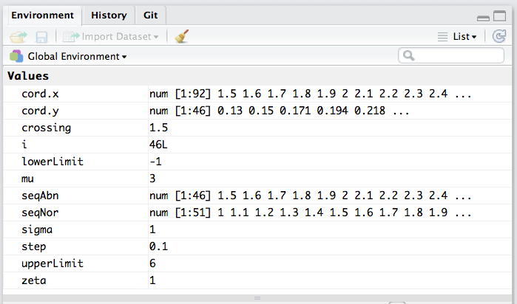

Figure : Environment window contents, code pointer at line 34.

Now look at lines 34 – 37:

for (i in seq(1,length(cord.x)/2)) {

cord.y <- c(cord.y,dnorm(cord.x[length(cord.x)/2+i]))

}

polygon(cord.x,cord.y,lty = 0, col='red')

It too has a for loop but this time the index of cord.x is offset by length(cord.x)/2 from the corresponding element in the previous for loop. In other words, one is using the other half of the cord.x array, starting at 5, and working back to 1.5:

> i <- 1; cord.x[length(cord.x)/2+i]

[1] 5

Moreover, this time one is using the *pdf* for the non-diseased cases (line 35; the default values for mean and sd are zero and unity, respectively). And every time one keeps augmenting the cord.y array, building up its length. So the end result is that the first half of the cord.y array corresponds to the red curve and the second half to the blue curve. The polygon is complete. All that remains is to call the polygon function line 37, with shading color red.

Clear any break points, exit debug mode, insert a beak point at line 39 and click on Source; the result is Figure 9.

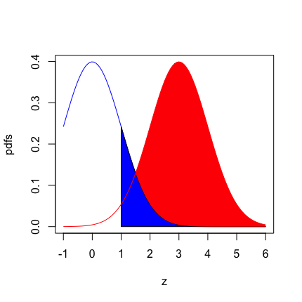

Figure : Result of running lines 1 – 37 in mainShadedPlotsSimple.R. The figure is almost complete except for the vertical lines.

It remains to fill in the common portion under the red and blue curves with vertical lines. The code, lines 39 – 47, is:

seqAbn <- seq(zeta,upperLimit,step)

seqAbn <- rep(seqAbn,each = 2)

for (i in seq(1,length(seqAbn), 2)) {

# define xs and ys of two points, separated only along y-axis

x <- c(seqAbn[i], seqAbn[i+1])

y <- c(0,dnorm(seqAbn[i+1], mu, sigma))

# draw vertical line between them

lines(x,y, col = 'red', lty = 1, lwd = 2)

}

Click on Next. Line 39 defines a new variable seqAbn extending from zeta to upperLimit in steps of 0.1.

Browse[2]> seqAbn

[1] 1.0 1.1 1.2 1.3 1.4 1.5 1.6 1.7 1.8 1.9 2.0 2.1 2.2 2.3 2.4 2.5 2.6 2.7 2.8 2.9 3.0 3.1 3.2 3.3 3.4 3.5 3.6 3.7 3.8 3.9 4.0 4.1 4.2

[34] 4.3 4.4 4.5 4.6 4.7 4.8 4.9 5.0 5.1 5.2 5.3 5.4 5.5 5.6 5.7 5.8 5.9 6.0

Browse[2]>

Click on Next. The code pointer should be at line 41. Using the function rep(), line 40 repeats each element of the above array twice (each = 2) and replaces seqAbn, which now has the values:

Browse[2]> seqAbn

[1] 1.0 1.0 1.1 1.1 1.2 1.2 1.3 1.3 1.4 1.4 1.5 1.5 1.6 1.6 1.7 1.7 1.8 1.8 1.9 1.9 2.0 2.0 2.1 2.1 2.2 2.2 2.3 2.3 2.4 2.4 2.5 2.5 2.6

[34] 2.6 2.7 2.7 2.8 2.8 2.9 2.9 3.0 3.0 3.1 3.1 3.2 3.2 3.3 3.3 3.4 3.4 3.5 3.5 3.6 3.6 3.7 3.7 3.8 3.8 3.9 3.9 4.0 4.0 4.1 4.1 4.2 4.2

[67] 4.3 4.3 4.4 4.4 4.5 4.5 4.6 4.6 4.7 4.7 4.8 4.8 4.9 4.9 5.0 5.0 5.1 5.1 5.2 5.2 5.3 5.3 5.4 5.4 5.5 5.5 5.6 5.6 5.7 5.7 5.8 5.8 5.9

[100] 5.9 6.0 6.0

Browse[2]>

Line 41 starts a for-loop with i in the sequence containing alternate elements of seqAbn; try it! Select seq(1,length(seqAbn), 2) and click on Run:

Browse[2]> seq(1,length(seqAbn), 2)

[1] 1 3 5 7 9 11 13 15 17 19 21 23 25 27 29 31 33 35 37 39 41 43 45 47 49 51 53 55 57 59 61 63 65

[34] 67 69 71 73 75 77 79 81 83 85 87 89 91 93 95 97 99 101

Browse[2]>

On the first pass of the for loop, line 43 defines x as c(seqAbn[i], seqAbn[i+1]), which is the same as the array c(1,1). Line 44 defines y as c(0,dnorm(seqAbn[i+1], mu, sigma)); the first element is zero and the second element is the *pdf* of the diseased distribution corresponding to the common value of x, namely unity. Line 46 uses the lines() function to draw a vertical line between the two points, each defined by two coordinates. The first point is (1,0) and the second point is (1, 0.054). This is repeated on successive passes of the for loop to indicate the common area under the non-diseased and the diseased distributions with vertical lines. Try experimenting with different values of the model parameters. The final result (not shown) is almost equivalent to book Figure 3.3, but lacks the panache of ggplot2.

# Online Appendix 3.I: Numerical integration in R

Open the file mainNumericalIntegration.R in the source-code window. The listing follows:

### Online Appendix 3.I.1: Code listing

#mainNumericalIntegration.R

rm(list = ls()); set.seed(1); #options(digits=3)

# numerically integrate pdf of N(0,1) from -infinity to infinty; should give unity

res <- integrate(dnorm, -Inf, Inf)

cat("integral from -inf to inf = ",res$value, "\n")

# numerically integrate the pdf of N(0,1) from 1.96 to infinty; should give 0.025

res <- integrate(dnorm, 1.96, Inf)

cat("integral from 1.96 to inf = ",res$value, "\n")

Line 4 uses the R function integrate() to numerically integrate the function named in the first argument (no parentheses needed after the name), dnorm, in the current example, from -∞ to ∞. Yes, R has a symbol for infinity, namely Inf (case sensitive). Since dnorm() is the *pdf* function, its integral over the entire range of *x* should yield unity. Go ahead and source the file. You should see the following output in the console window.

### Online Appendix 3.I.2: Code output

> source(…)

integral from -inf to inf = 1

integral from 1.96 to inf = 0.025

**A brief digression into lists**: Notice that the result of the integration, line 4, is assigned to the variable res and that in printing (“cat”-ing) the result one used the construct res$value. If one looks in the Environment panel (upper-right) of the RStudio interface, Figure 10, one sees that res is a List of 5. Clicking on the arrow next to res yields the additional information that the list consists of several list variables: value, abs.error, and various other quantities that need to be signaled after a properly conducted numerical integration, see Figure 10.

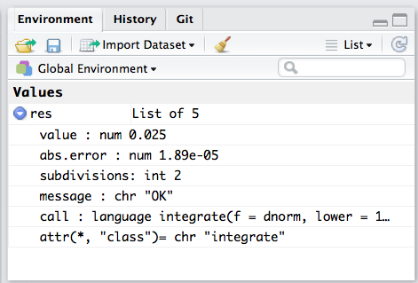

Figure : Environment window showing contents of variable returned by the integrate function.

For example, the list variable value has a member named value (sic) 0.025 (this is the expected 0.025 resulting from the integration). The quantity abs.error is 1.89e-05, the absolute error of the numerical integration. *To extract the value of a specific list variable, for example “value”, use* res$value. This says, “starting with the list variable res, what is the value of the specific member of this list that is named value”. Try typing the following into the Console window:

### Online Appendix 3.I.3: Code snippets

> res <- integrate(dnorm, -Inf, Inf)

> names(res)

[1] "value" "abs.error" "subdivisions" "message" "call"

> res$Value

NULL

> res$value

[1] 1

> res$abs.error

[1] 9.36e-05

> res$subdivisions

[1] 3

> res$message

[1] "OK"

> res$call

integrate(f = dnorm, lower = -Inf, upper = Inf)

The second line introduces the R function names() which gives the names of the members of the list supplied as argument to this function. To get further details of the integrate() function type integrate in the search window of the Help panel in the RStudio interface. Or select it and click on the tab button on one's keyboard. Or go to the R web site.

Getting back to numerical integration, line 7 numerically integrate the *pdf* of the unit normal distribution from 1.96 to infinity; this should give approximately 0.025. So far one has been limiting the number of decimal places, but now one needs more than 3 decimal places (look at line 1: the author have commented out the options call.). One may need to restart R by going to the Session menu (main menu of RStudio) as otherwise any pre-existing value of options will apply. Now source the file. The output is:

### Online Appendix 3.I.4: Code snippets

> source(…)

integral from -inf to inf = 1

integral from 1.96 to inf = 0.0249979

# References

1. Wilkinson L. *The grammar of graphics.* Springer Science & Business Media; 2006.

2. Van Dyke CW, White RD, Obuchowski NA, Geisinger MA, Lorig RJ, Meziane MA. Cine MRI in the diagnosis of thoracic aortic dissection. *79th RSNA Meetings.* 1993.